24.73: a) 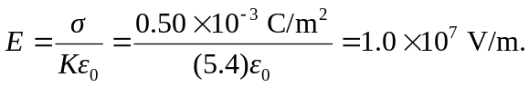
b) The outside is at the higher potential.
c) volume 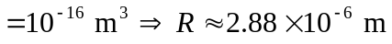
 shell volume

